Bash-Scripting
Bash scripting: Bash scripting is the automation of Linux commands by writing them into a script file (.sh) that Bash executes line by line.
Create a script:
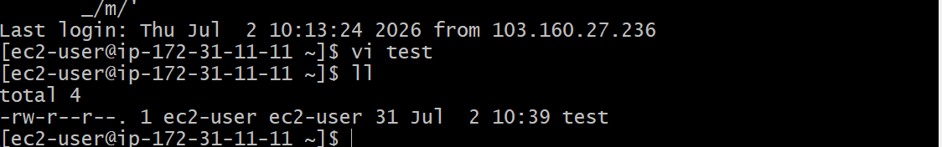
To give permissions chmod 755 test
To execute the script:./scriptname(ex:./test)
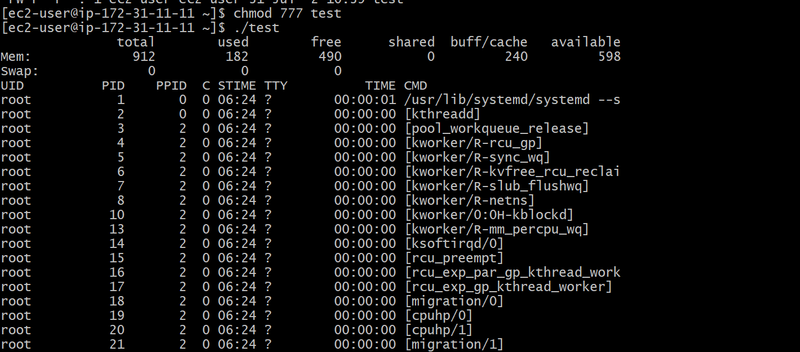
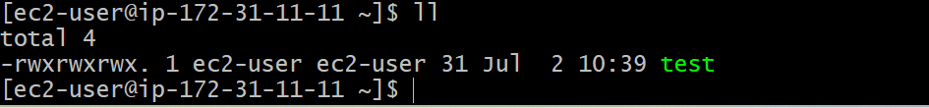
Echo $0 –details of the current shells
Cat /etc/shells- shows different type of shells installed in linux
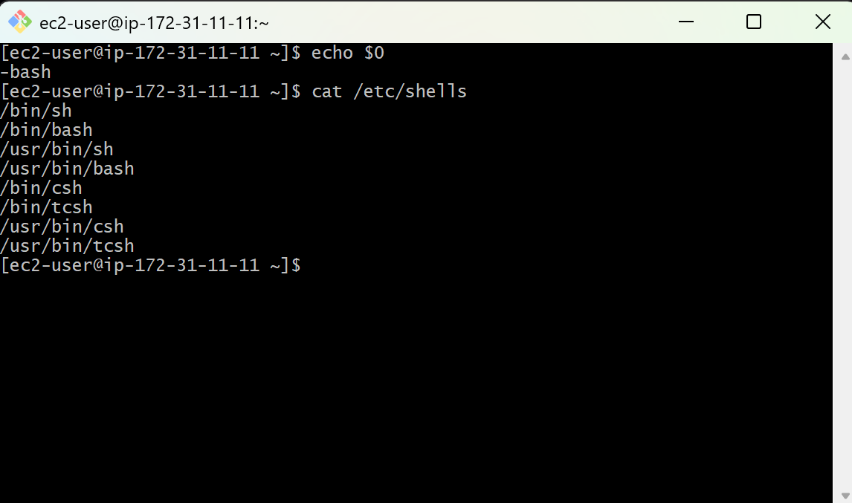

Create a directory:
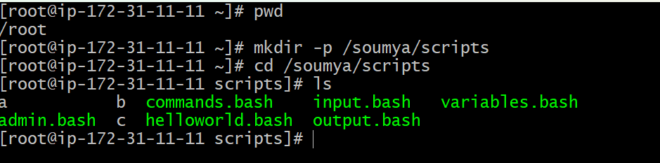
Script format:
Script: set of commands which helps to automate the process
Steps which will help the other users to understand
- Define shell(#!/bin/bash)
- Comments(#comments)
- Define variables(eg name=Soumya)
- Commands(echo,grep,cp etc)
- Statements(if ,while,for etc)
Step by step process:
Create a script
Add a script content and save it
Give execute permissions
Run a script

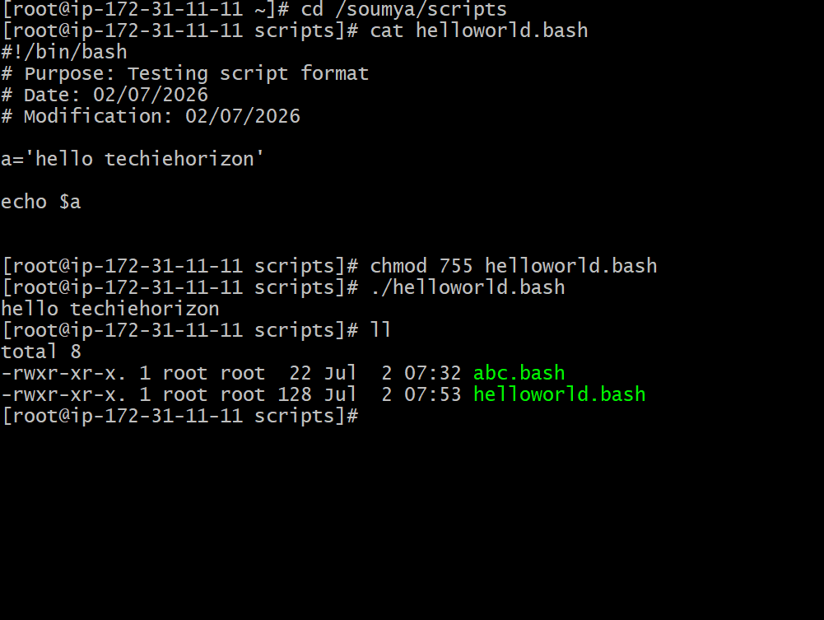

Sequence of the script:
Sequence will execute from top to bottom
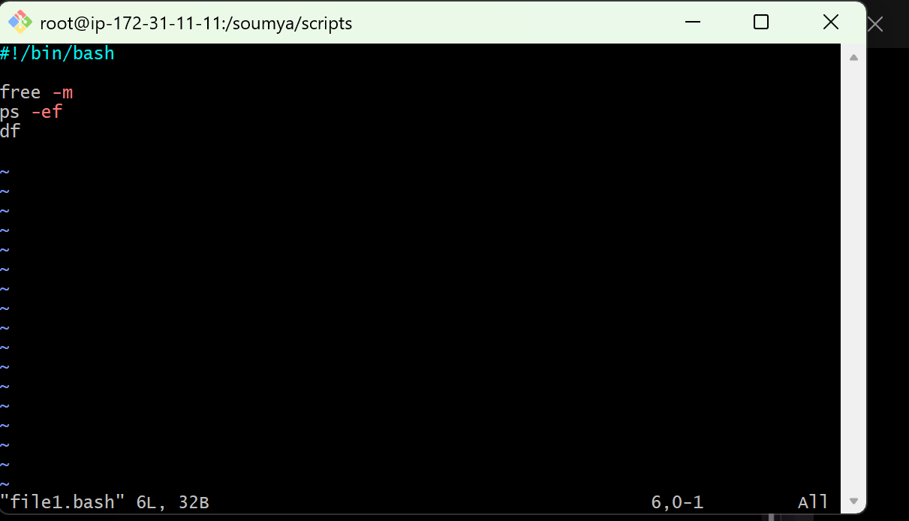
Create a basic script with output: Hello World!
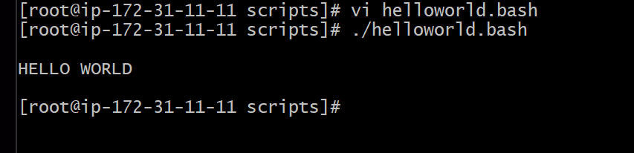
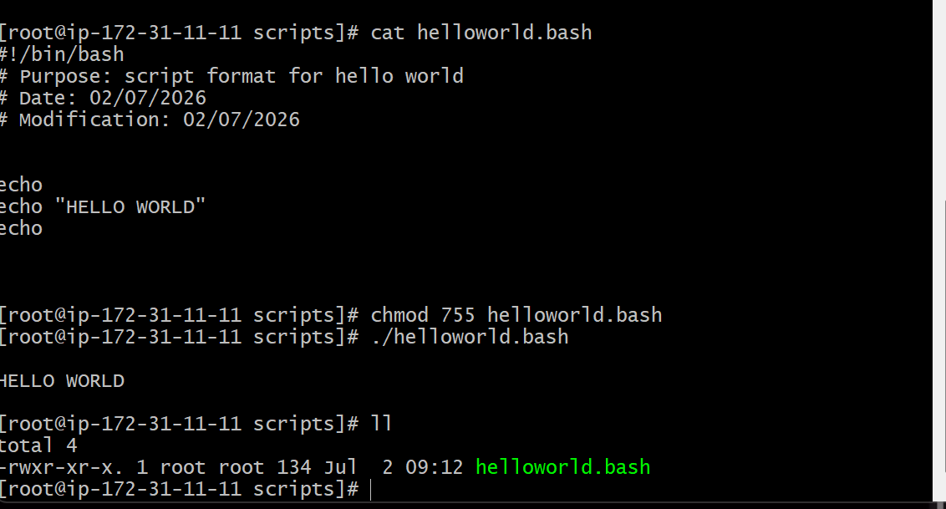
Basic Second script:
Example: created vi commands.txt

Write
Pwd
Ls
whoami
date
cal
touch a b c
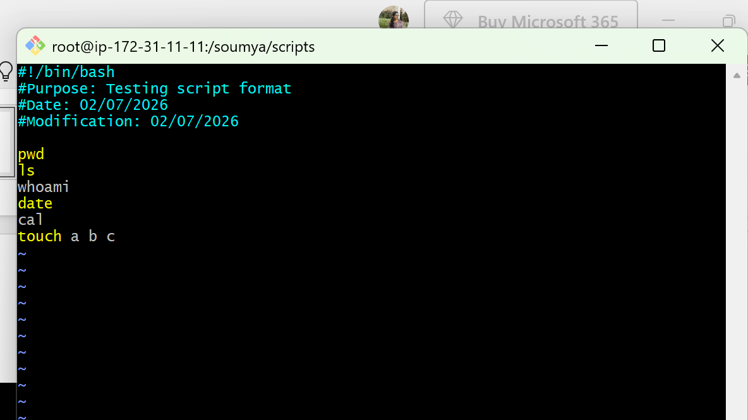
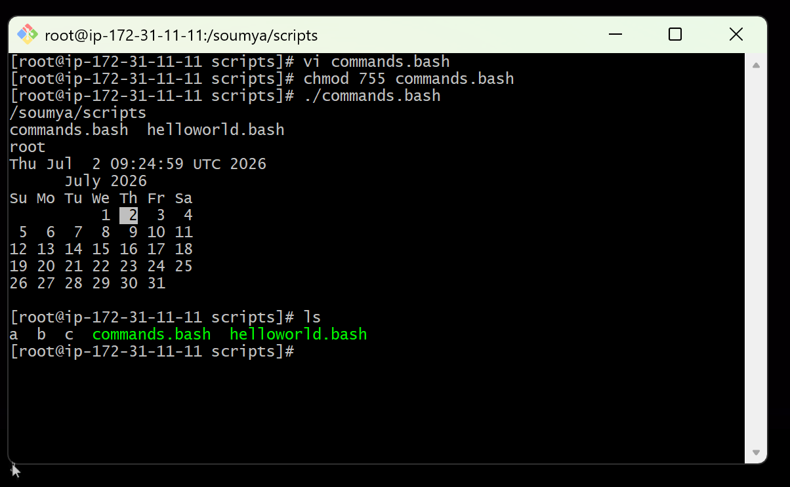

Basic Administration Tasks:
vi admin.bash
write
top
df -h
free -m
uptime
iostat
top get stucks because that will conitnously montior.
So top | head -10
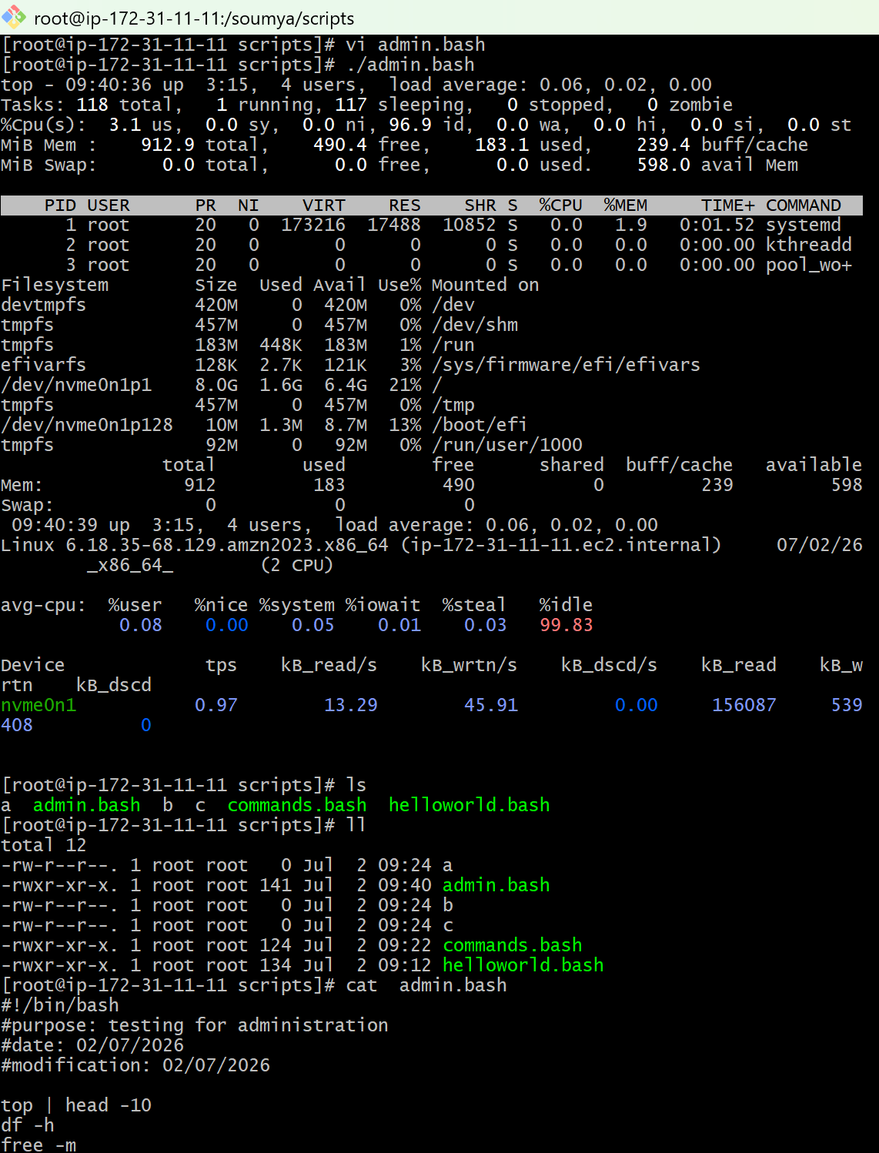
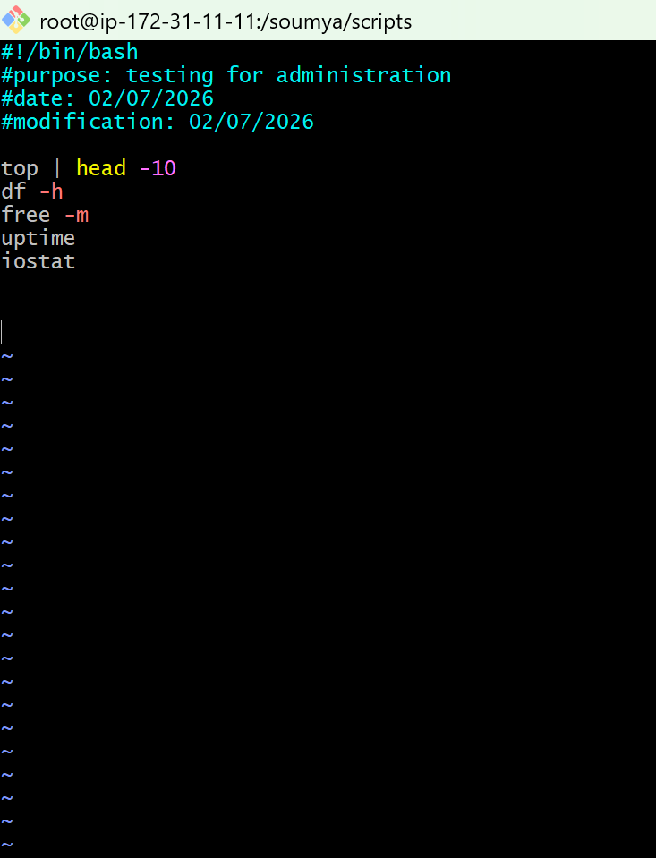
Defining variables:
A variable is value that can change, depending on conditions or an information passed to the programs
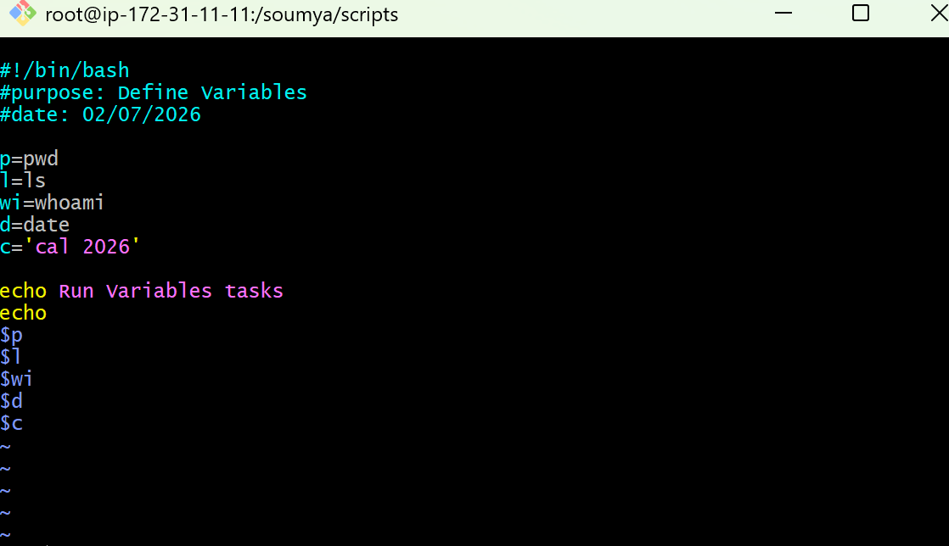
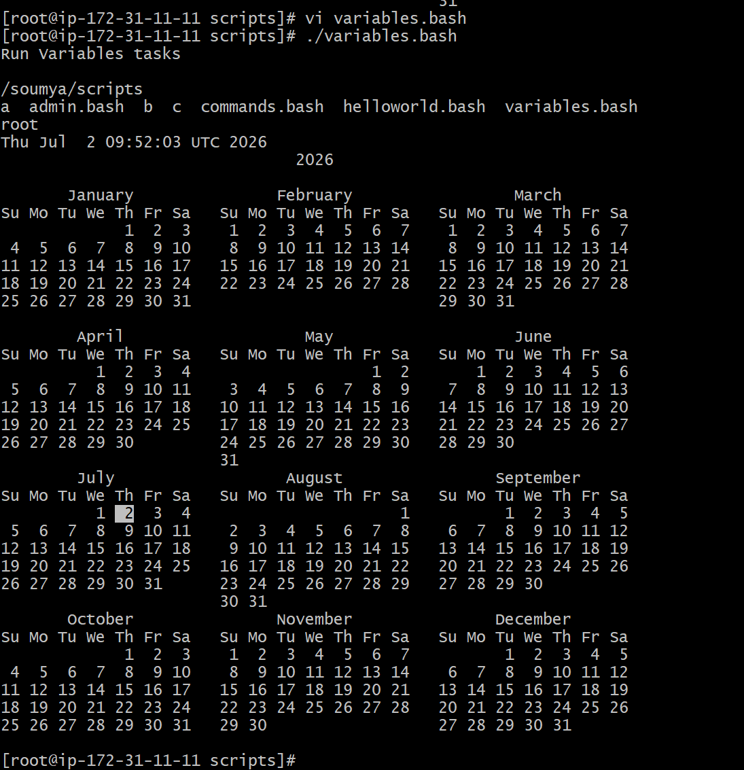

Input/Output script:
Read – it takes input from user
Echo – prints the output
Example1:
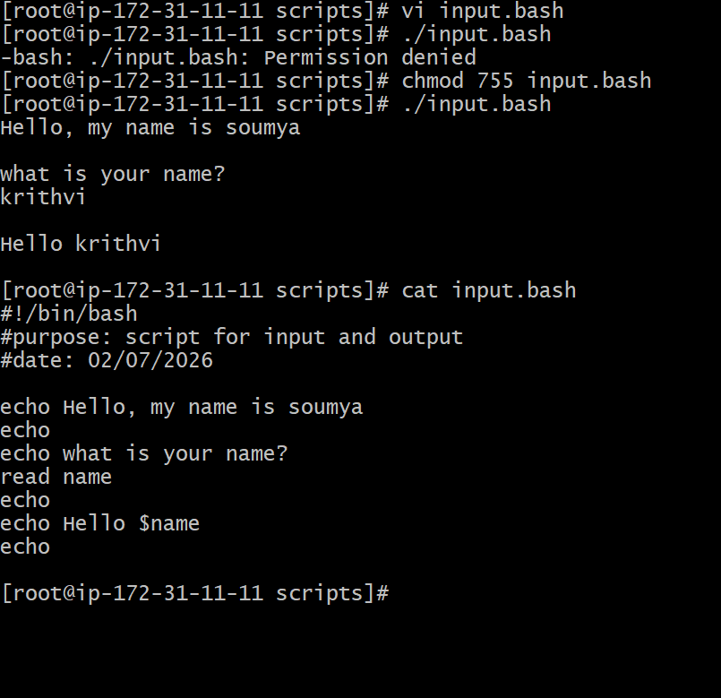
Example2:
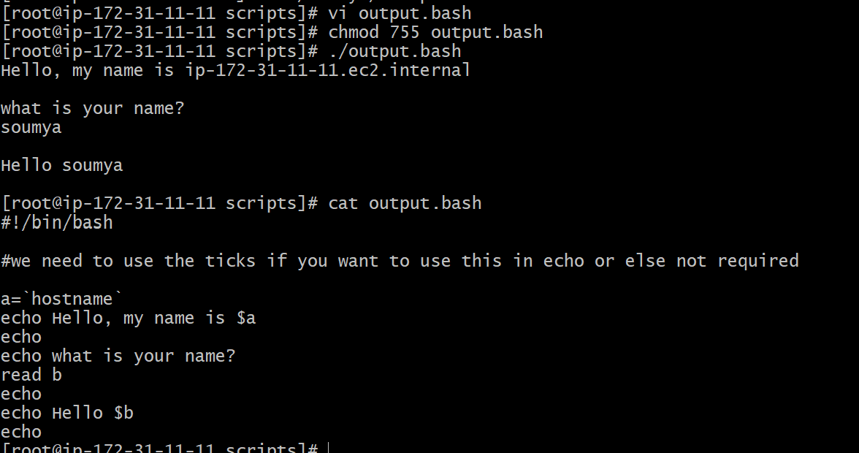
Basic shell script examples:
Example 1:
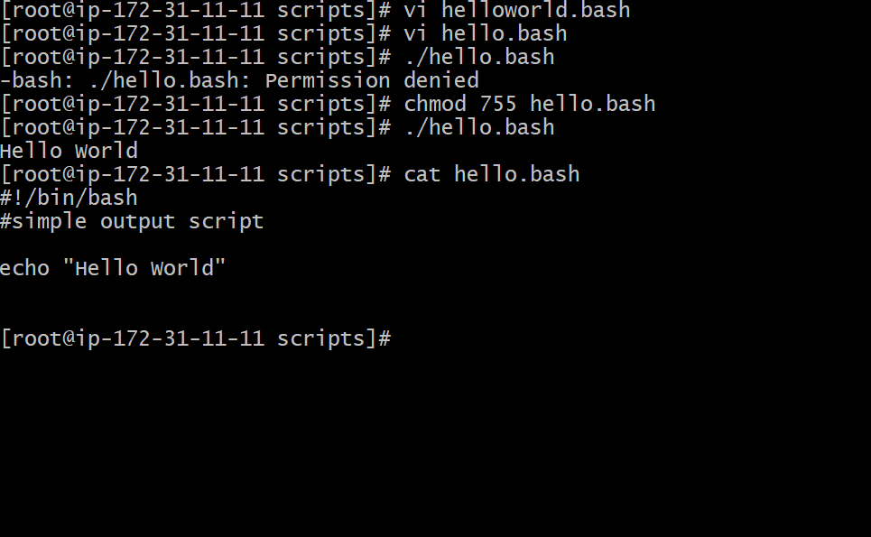
Example 2: Defining Tasks
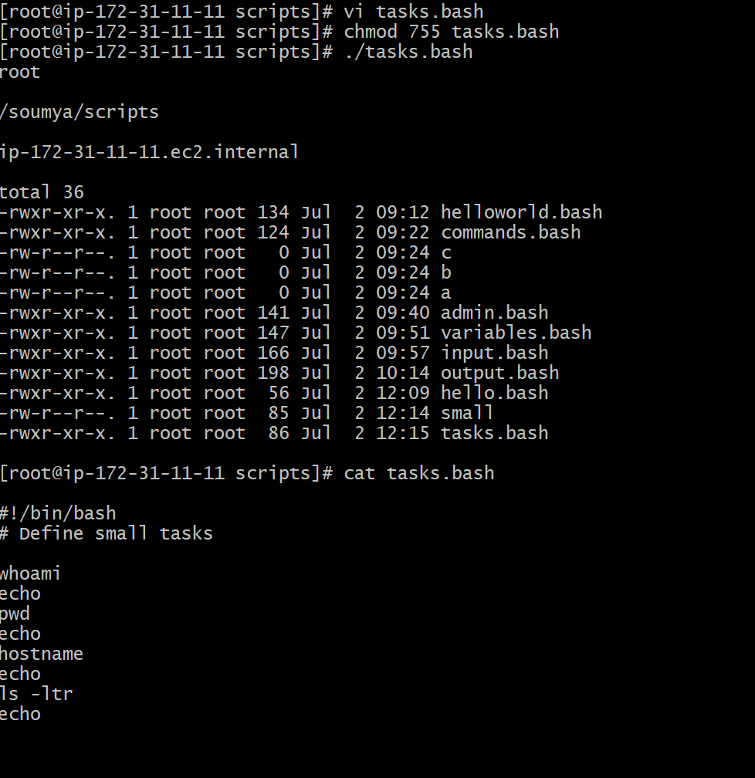
Example3: Defining variables
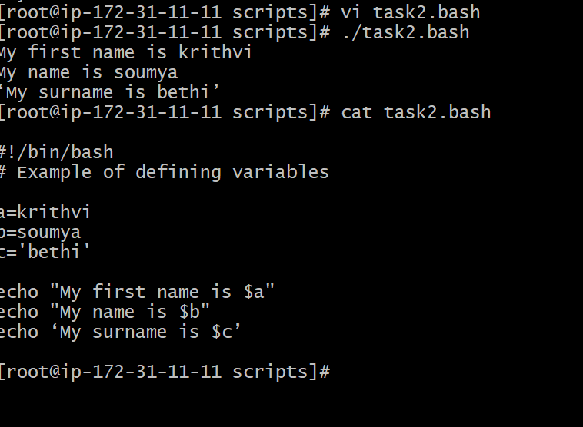
Example4: Read Input
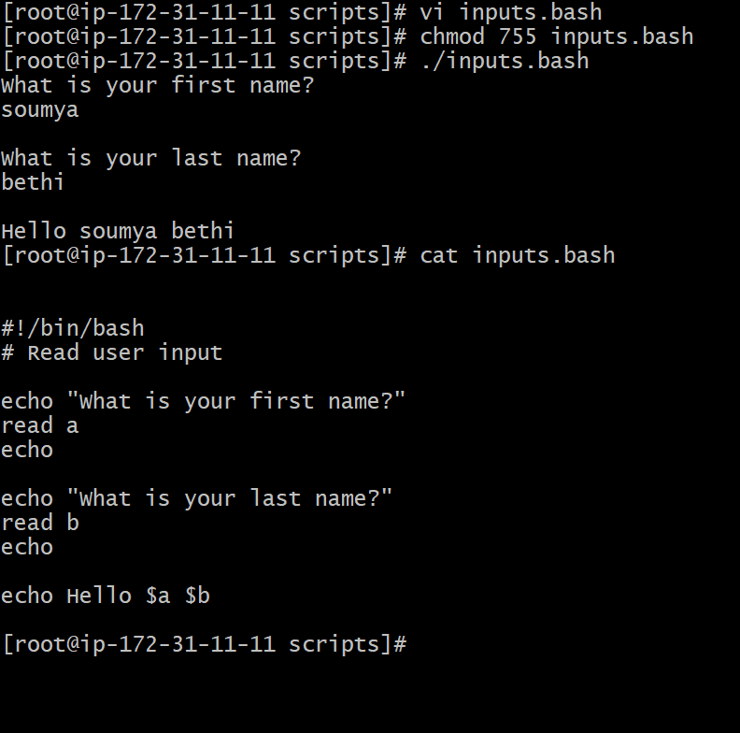
Example5: Scripts to run commands within
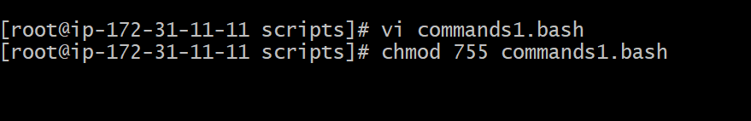
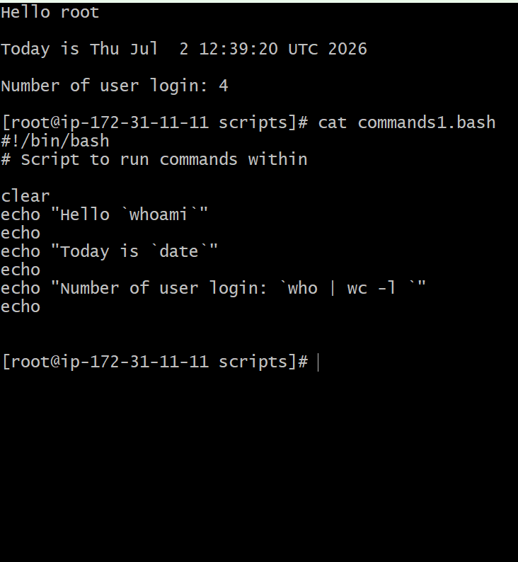
Example 6: Read input and perform a task

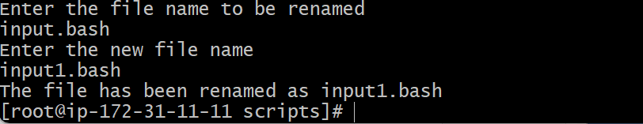
For loop :
#!/bin/bash
for i in 1 2 3 4 5
do
echo "Welcome $i times"
done
